**Quote of the day**

*“No one is perfect - that's why pencils have erasers.”*

**Assignment # 1**

**Theory of Automata**

**CS301**

**Sections C, F and G**

**Weightage 5**

Due Date: 05-03-2021

1. Compliance with deadline is must because there would be no fluctuation in deadline
2. For any query you can contact me.
3. Try to solve assignment by your own as copying would not enable you to learn.
4. You should try to have discussion with your friends if you have confusion.
5. You can email me also in case of confusion.

Regular Expressions

1. Find the regular expression of the following sets

L1 = {$a^{n}b^{m}:\left(n+m\right) is even\}$

L2 = $\{a^{n}b^{m}, n≥4, m≤3\}$

L3 = $\{a^{n}b^{m}, n<4, m≤4\}$

L4 = $\{a^{n}b^{m}:n≥1, m≥1, nm≥3\}$

L5 = $\{ab^{n}w:n≥3 , w∈{\left\{a, b\right\}}^{+}\}$

L6 = $\{vwv:v, w∈{\left\{a,b\right\}}^{*}, \left|v\right|=2$

L7 = having exactly one pair of consecutive zeros.

L8 = having exactly one a.

L9 = strings containing no more than 3 a’s

L10 = all strings that contain at least one occurrence of each symbol in alphabet

L11 = all strings ending in 0, 1.

L12 = all string not ending in 0, 1

L13 = All strings containing even number of zeros.

L14 = all string having at least two occurrences of substring 00.

L15 = all strings not containing 101.

L16 = $\{w :\left|w\right|mod 3=0\}$

L17 = $\{w :n_{a} \left(w\right) mod 3=0\}$

1. I each of the following part the draw the FA accepting the indicated language over the alphabet {a, b}. Also mentioned the Regular expressions for the mentioned languages.

a. The language of all strings containing exactly two a’s.

b. The language of all strings containing at least two a’s.

c. The language of all strings that do not end with ab.

d. The language of all strings that begin or end with aa or bb.

e. The language of all strings not containing the substring aa.

f. The language of all strings in which the number of a’s is even.

g. The language of all strings in which both the number of a’s and the number of b’s are even.

h. The language of all strings containing no more than one occurrence of the string aa. (The aaa string contains two occurrences of aa.)

i. The language of all strings in which every a (if there are any) is a followed immediately by bb.

j. The language of all strings containing both bb and aa as substrings.

k. The language of all strings containing both aba and bab as substring.

1. For the following FAs write down the languages and regular expressions.

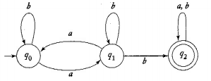



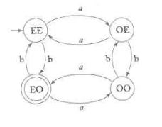



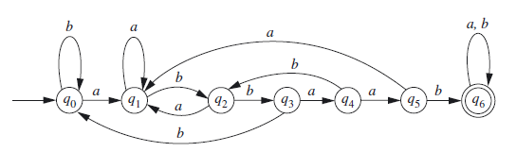



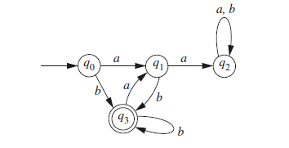



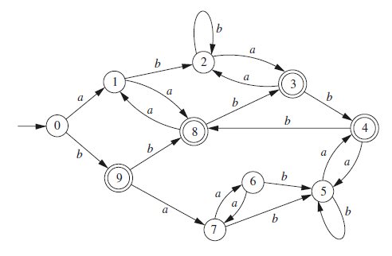



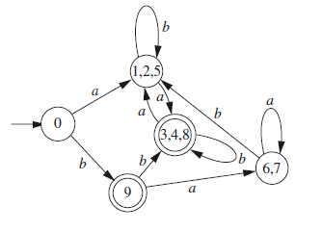



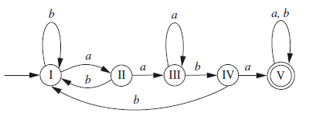



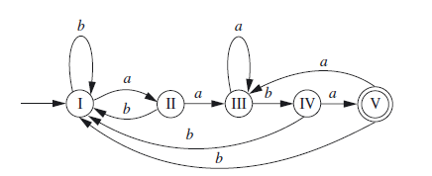



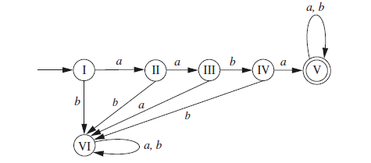



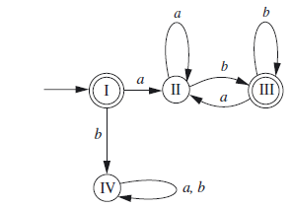



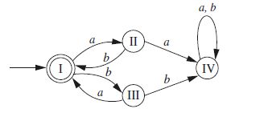



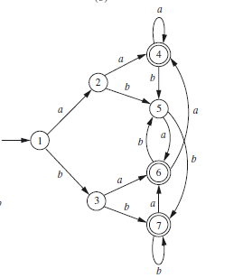

Q 3. Simulate these automata mentioned in Q3 using the simulator mentioned below.

Q4. Use the python library <https://pypi.org/project/python-statemachine/> for simulating any 5 automata of your choice.

Q5. Discuss your experience of solving Q.4.

Q6. Derive the regular expression which should comply with the variable declaration rules in C.

Q7. Make a python program of 5 regular expressions of your choice **(Bonus Question)**